**You may choose from these frames (must be employed for 30 days or more)**

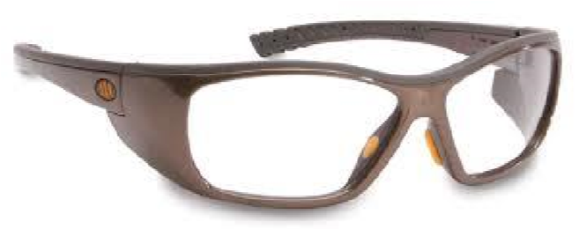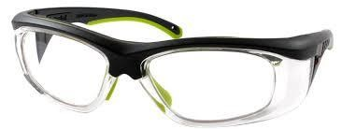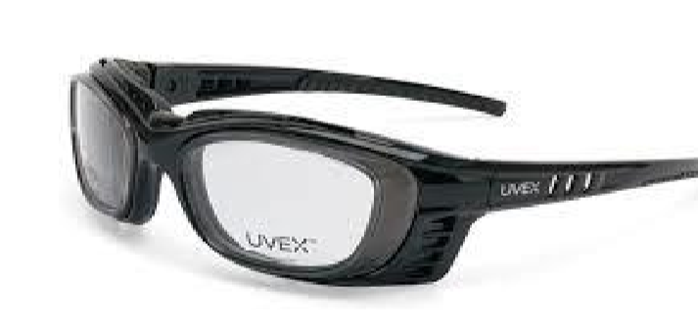

# PENTAX ZT200 UVEX SW09 UVEX SW07

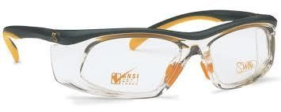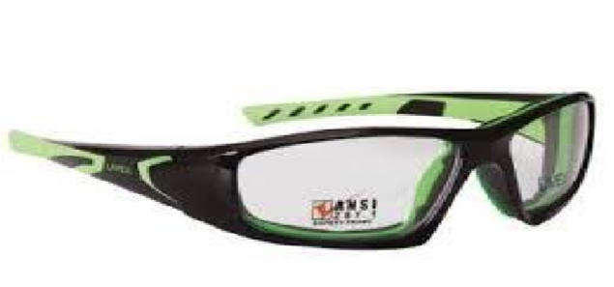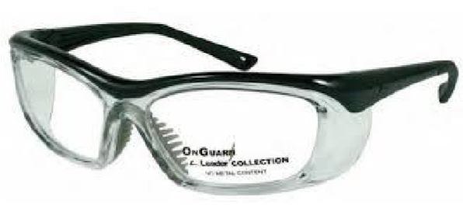

UVEX SW12 UVEX SW06 OG 220S

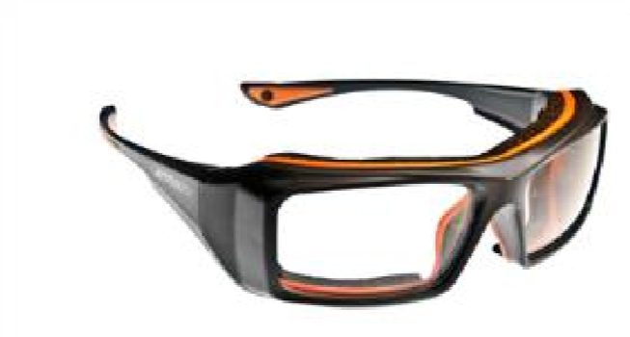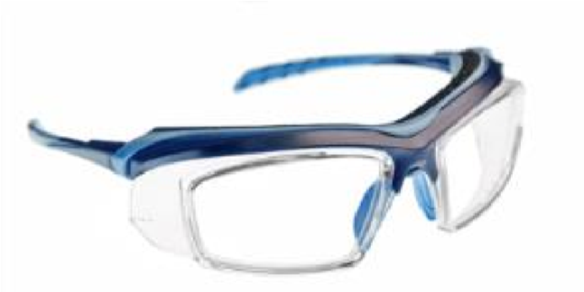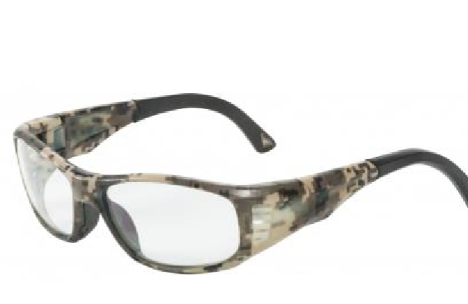

OG 240S AX 6006 AX 6008

**The company will cover your frame (various sizes & colors available) and lenses.**

Approved add-ons, paid by you, are: Digital Progressive and/or Standard Non-Glare Coating

You must bring a current Rx (2 years old or newer)

**Locations**

|  |  |  |
| --- | --- | --- |
| **City** | **Company** | **Address** |
| Any listed | Any ***Walmart Vision*** location – including Elkhart & Sturgis  *Wrap-around-style* frames up to $39+tax are covered.  Snap-on or slide-on sideshields are not permitted. | 175 CR-6 Elkhart  30830 Old US-20 Elkhart  4522 Elkhart Rd. Goshen  1500 S. Centerville Rd. Sturgis |
| Elkhart | MyEyeDr (ONLY the Concord Mall location) | 3701 S. Main St |
| Niles | Rx Optical | 1421 S. 11th St. |
| Three Rivers | Rx Optical | 11 N. US Hwy 131 |
| Sturgis | Rx Optical | 500 S. Centerville Rd |
| Warsaw | Rx Optical | 2250 N. Pointe Dr. |

**\* There are additional locations, visit Walmart.com and click “Services” Health & Wellness, Vision Center**

**or RxOptical.com for hours of operation**