# 

# Accessing Your Employee Self Service Portal

In order to change your address and dependent information or view check stubs, W2s, tax information, and other company documents, employees must log into the Employee Self Service website.

## **Logging in to the Application**

1. Access your company’s URL for the application
   1. <https://secure2.saashr.com/ta/PayServ172001.login>
2. Enter your Username and Password
   1. Username: Employee ID
   2. Initial Password: last 4 digits of your social security number
3. Click the LOGIN button

cid:image002.png@01D6762F.A6EA6D10

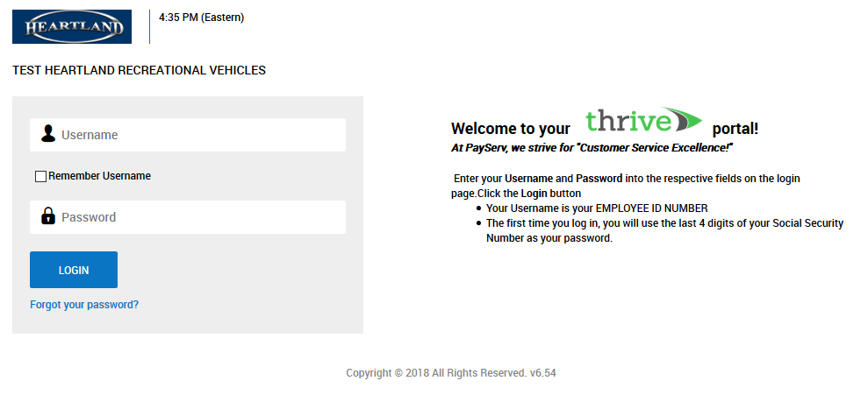

## **Changing your Password**

Upon your first login, and at each 90 days, you will be required to change your password.

1. Enter your old password (for the first login, this will be the last 4 digits of your social security number)
2. Enter your new password twice (must contain at least 8 characters and have at least one of each of the following: capital letter, lowercase letter, number, symbol)
3. Click the CHANGE button

cid:image002.png@01D6762F.A6EA6D10  
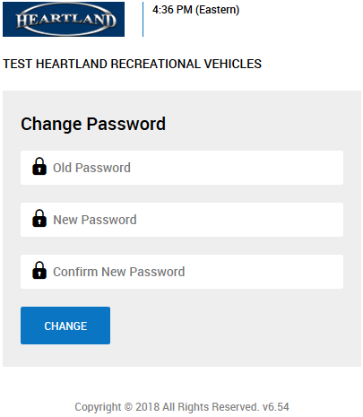

## **Configure your Virtual Code Settings**

1. From the Virtual Code Settings Configuration screen, either select from existing values (available in the drop downs), or enter new values for the three provided virtual code setting methods. You must have at least 1 option configured.
2. Once finished, click SAVE
3. Select one of the following methods in order to validate your identity: Text message, Voice, Email
4. Click SEND to send code via the method you have selected.
5. Enter code into the Enter Code Box
6. Check the box to remember your computer and browser
7. Click on CONTINUE

cid:image002.png@01D6762F.A6EA6D10cid:image002.png@01D6762F.A6EA6D10

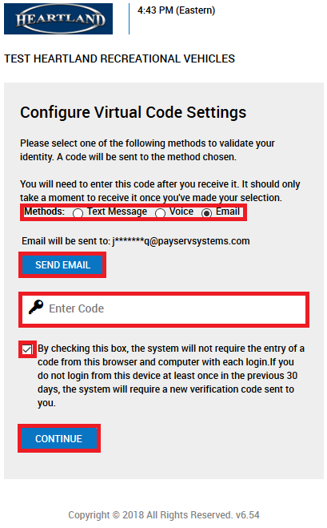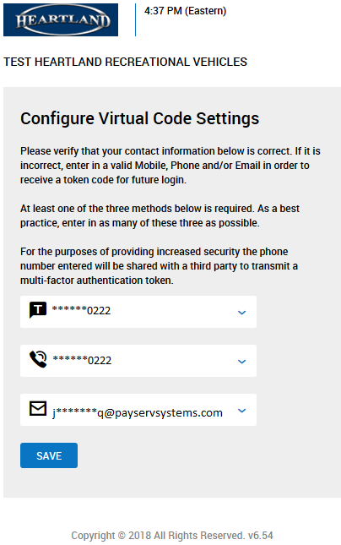

## **Navigating the Portal and Dashboard Links**

Your Dashboard (home screen) will include quick access to company announcements, your weekly schedule, time off requests, quick links, accrual balance, and company events. The top navigation of your portal will show My Account and Our Company.

Options under My Account include:

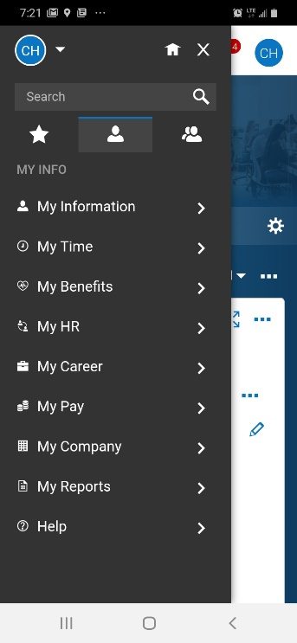

* My Information – Here you can request updates to your personal information including emergency contacts, address, phone number, and email address
* My Time – Here you can view timesheets, time off, and clock in/out times
* My Benefits – Here you can view your Benefit plans
* My HR – Here you can view forms such as; Attendance policy, Company handbooks, W2’s, Withholdings, etc.
* My Career – Here you can view performance and/or incidents
* My Pay – Here you can view pay history, forms, direct deposits, tax information, etc.
* My Company – Here you can view announcements, events, documents, and charts

**Mobile Application**

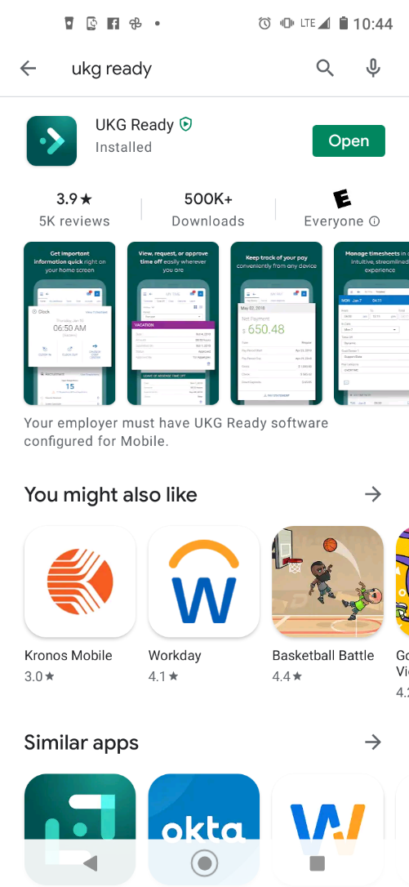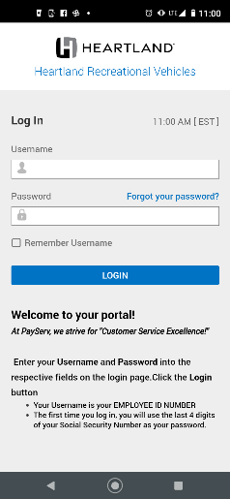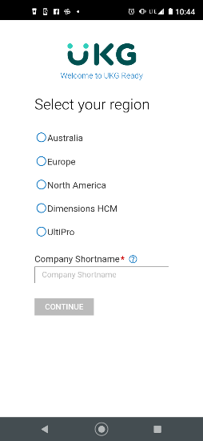The mobile application is called “Kronos Workforce Ready Mobile” and is available for free in your app store. When logging in to the mobile app, you will use the company short name **PayServ172001** and your normal username and password.

**PLEASE NOTE:**

* Your first login must be within **14** days of your account creation, or your account will lock
* Too many failed login attempts (**5**) will lock your account. To unlock, contact HR
* Any time you change devices, you will be **required** to verify with the virtual code authentication process
* If you have forgotten your password, please use the **Forgot Password** link on the login screen to reset your password.